Birth to Twenty: the assessment of physical development in adolescence
Year 14
ID:
Female
Section A
We would like to ask you a few questions about your physical development.

Question 1
Have you grown taller in the last 6 months?
(Please mark the appropriate block)

No Yes, a little Yes, some Yes, a lot Don’t know

Question 2
Have you started puberty (i.e. do you have pubic hair or have your breasts enlarged)? (Please mark the appropriate block)

No Yes

Question 3
Have your breasts started to develop (grow) yet?
(Please mark the appropriate block)

No Yes, a little Yes, some Yes, a lot Don’t know

Question 4
Do you have any hair underneath your arms or in the pubic region?
(Please mark the appropriate block)

No Yes, a little Yes, some Yes, a lot Don’t know

Question 5
Has your skin started to change (pimples)?
(Please mark the appropriate block)

No Yes, a little Yes, some Yes, a lot Don’t know

Question 6
Have you begun to menstruate (have your period)?
(Please mark the appropriate block)

No Yes

Question 7

If Yes to Question 6, at what age did you begin to menstruate?

Question 8
If Yes to Question 6, do you have regular menstrual cycles (periods)?
(Please mark the appropriate block)

No Yes

Question 9
If Yes to Question 6, have you been having periods for more than two years?
(Please mark the appropriate block)

No Yes

Section B
The drawings below show different amounts of pubic hair. A teenager passes through each of the five stages shown by these drawings. Please look at each drawing and read the sentences under the drawings. Then choose the drawing closest to your stage of hair development and mark it.
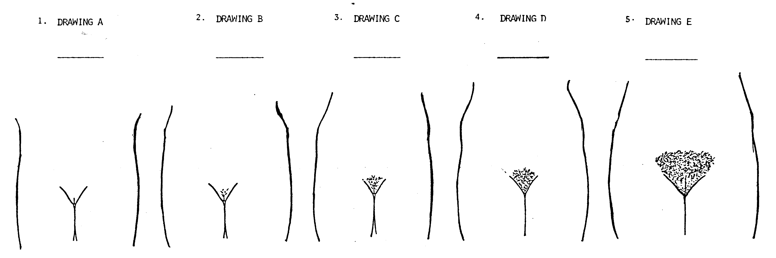

There is no pubic hair
Texture of the hair is soft.
Density of the hair is little.
Distribution of the hair is along the mid-line. Pubic hair may be straight or curly
Texture of the hair is coarse.
Density of the hair is that of an adult.
Distribution of the hair has spread to the thighs and moved up the mid-line.
Texture of the hair is coarser.
Density of the hair is a little more.
Distribution of the hair has spread out thinly, up the mid-line, and covers a somewhat larger area.
Texture of the hair is coarse.
Density of the hair is much more.
Distribution of the hair covers a large area in a triangular shape, but has not spread to the thighs. The hair is a darker colour.

Section C

The drawings below show the different stages of development of breasts. A teenager passes through each of the five stages shown by these sets of drawings. Please look at each set of drawings and read the sentences under the drawing. Then choose the set of drawings closest to your stage of breast development and mark it.
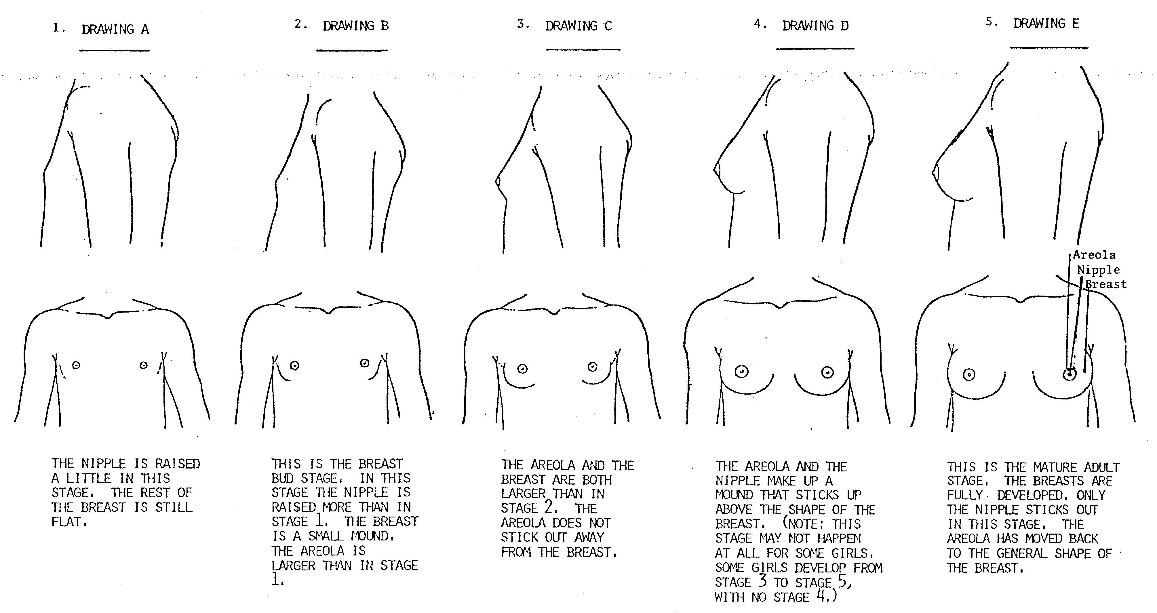

The breast is flat.
The breast is a small mound. The areola (circle around the nipple) is larger. The nipple is slightly raised.
The breasts are fully developed and extend to the arm pit, there are small bumps on the areola around the nipple, and only the nipple sticks out in this stage.
The areola circle has gotten bigger, and the breast has increased in size and more cone-shaped

The areola and the nipple make up a mound that sticks up above the shape of the breast. Small bumps may be developing on the areola. The breast may have gotten bigger and rounder.

Interviewer

